Infosec Train

🔹 Definition
# Source: ScreenShots Source: Provided by: [Persons Table -> ID Column: 1, Name_En Column: Motasem Essam] -> Tool: [Lightshot Program] -> From [Site: https://www.infosectrain.com/] on [1/23/2026]
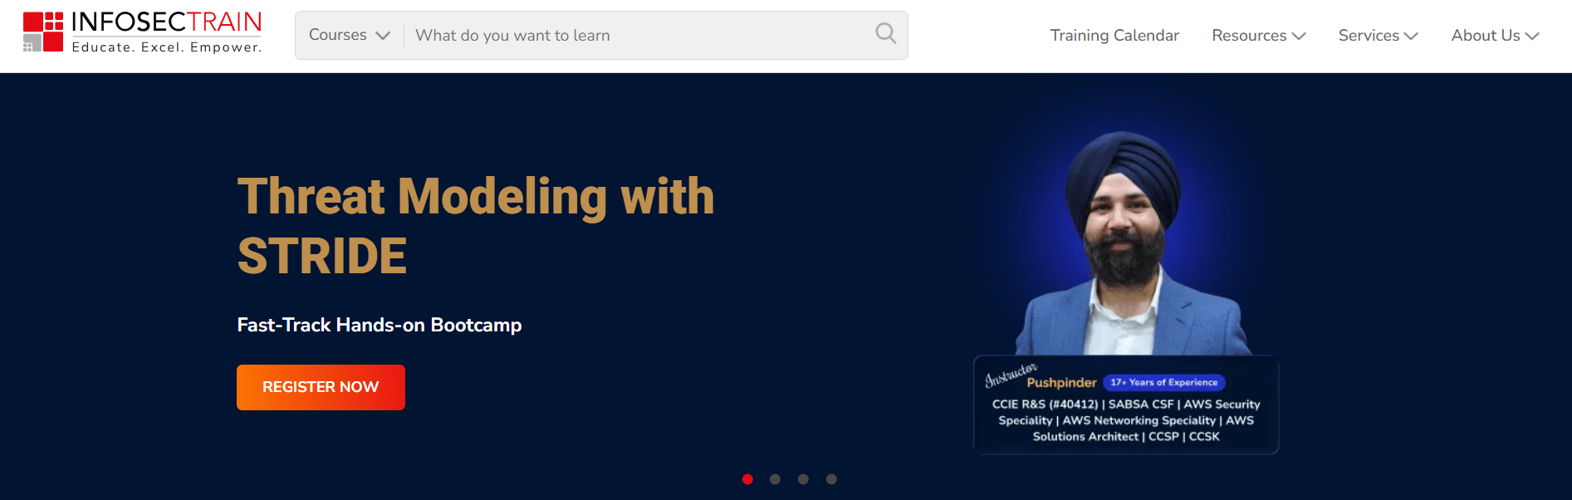
# Source: AI Source: Provided by: [Data Path: Persons Table -> ID Column: 1, Name_En Column: Motasem Essam] -> From: [ChatGPT] on [1/23/2026]
InfosecTrain (accessible at https://www.infosectrain.com) is a global cybersecurity training and consulting organization that focuses on educating individuals and enterprises in information technology and security skills. (infosectrain.com)

🔐 What It Is
# Source: AI Source: Provided by: [Data Path: Persons Table -> ID Column: 1, Name_En Column: Motasem Essam] -> From: [ChatGPT] on [1/23/2026]
- Cybersecurity & IT training provider: InfosecTrain offers a wide range of courses, certification prep programs, and hands-on training in cybersecurity domains such as SOC analysis, penetration testing, cloud security, governance & compliance, and more. (infosectrain.com)
- Consulting & customized solutions: They tailor training programs to the specific needs of organizations and professionals, including live instructor-led sessions, virtual classes, and practical labs. (infosectrain.com)

🧠 Key Features
# Source: AI Source: Provided by: [Data Path: Persons Table -> ID Column: 1, Name_En Column: Motasem Essam] -> From: [ChatGPT] on [1/23/2026]
- Role-focused certification training: Programs geared toward recognized certifications like CISSP, CompTIA Security+, CEH, CCSP, ISO 27001 Lead Auditor, and other IT security qualifications. (infosectrain.com)
- Hands-on practical learning: Courses include practical exercises, real-world scenarios, and labs to build skills in both offensive (ethical hacking, red team) and defensive (SOC, incident response) cybersecurity areas. (infosectrain.com)
- Global reach: They serve learners and corporations worldwide and aim to empower professionals with future-ready cybersecurity expertise. (infosectrain.com)

📍 Background
# Source: AI Source: Provided by: [Data Path: Persons Table -> ID Column: 1, Name_En Column: Motasem Essam] -> From: [ChatGPT] on [1/23/2026]
- Founded: 2016 by experienced IT security professionals. (infosectrain.com)
- Headquarters: Based in Noida, Uttar Pradesh, India with global learners and corporate clients. (LinkedIn)
- Industry: Education, professional training, and coaching in cybersecurity and IT. (LinkedIn)
In simple terms, InfosecTrain is like an academy for cybersecurity and IT professionals, offering structured training and certification preparation to help people build and advance careers in digital security. (infosectrain.com)

